Sales Performance & Growth Opportunities

Dashboard Planning and Design Strategy
Week 2 Task
Prepared by: Mukesh Samarit
Course / Module: Virtual Tableau Visualization Intern
Date: 29 August 2026

1. Context and Business Problem
Context
The marketing manager is responsible for driving sales growth by identifying high-potential products, regions, and customer groups, as well as addressing performance bottlenecks and risks. Sales data is available at the order level, including revenue, discounts, delivery times, and customer ratings across regions and product categories.
Business Problem
Currently, the marketing manager lacks an interactive, consolidated view of sales performance that highlights:
- Where bottlenecks or risks exist (e.g., slow delivery, low customer ratings, heavy discounting).
- Which product categories, regions, or customer groups are underperforming or have the highest growth potential?
This makes it difficult to prioritize marketing campaigns, promotions, and operational improvements effectively.
Dashboard Purpose
The dashboard will enable the marketing manager to:
- Monitor sales performance across time, regions, and product categories.
- Identify bottlenecks and risks using delivery time, discount levels, and customer satisfaction.
- Pinpoint high-opportunity product categories, regions, and customer segments to push or fix.

2. Target Audience and Key Questions

2.1 Target Audience
- Primary User: Marketing Manager
  - Uses the dashboard weekly to review sales performance and decide where to focus campaigns and promotions.
  - Needs a clear overview with the ability to filter by region, product category, and time.
- Secondary Users: Marketing Analysts, Sales/Operations Stakeholders
  - Use the dashboard to investigate specific issues and align on priorities (e.g., delivery improvements, promotional focus).

2.2 Key Questions
The dashboard should help answer:
- What is the current sales performance (revenue) by month, region, and product category?
- Which regions and product categories are generating the most and the least revenue?
- Where are the biggest bottlenecks or risks in terms of:
  - High average discounting?
  - Long delivery times?
  - Low customer ratings?
- Which product categories and regions show the best combination of high revenue and high customer satisfaction?
- Which areas (region × product category) should be prioritized for:
  - Marketing push (high potential, good performance)?
  - Operational fix (poor delivery or low ratings)?
  - Pricing/promotion review (excessive discounting)?

3. Metrics and Visual Elements

3.1 Primary KPIs
These will appear as summary cards at the top of the dashboard.
- Total Revenue
  - Definition: Sum of revenue over the selected time period.
  - Direction: Higher is better.

- Average Order Value (AOV)
  - Definition: SUM(revenue) / COUNT(DISTINCT order_id)
  - Direction: Higher is better.

- Average Discount (%)
  - Definition: AVG(discount)
  - Direction: Lower is generally better (less discounting).

- Average Delivery Days
  - Definition: AVG(delivery_days)
  - Direction: Lower is better.

- Average Customer Rating
  - Definition: AVG(customer_rating)
  - Direction: Higher is better.

3.2 Visual Elements
- KPI Summary Cards – Total Revenue, AOV, Avg Discount, Avg Delivery Days, Avg Rating.
- Trend Over Time – Line chart: Revenue by Month.
- Performance by Region – Bar chart: Revenue by Region.
- Performance by Product Category – Bar chart: Revenue by Product Category.
- Bottlenecks & Risks – Scatter plot:
  - X: Avg Delivery Days
  - Y: Avg Customer Rating
  - Size: Revenue
  - Color: Region or Product Category.
- Detail Table – Region × Product Category with:
  - Revenue, Order count, Avg Discount, Avg Delivery Days, Avg Rating.

4. Layout Strategy

4.1 Information Architecture
The dashboard follows a top-to-bottom narrative:
- Header & Global Filters
- KPI Summary
- Trend Over Time
- Performance by Region & Product Category
- Bottlenecks & Risks
- Detail View

4.2 Layout Plan (Sections)
- Header & Global Filters
  - Title: “Sales Performance & Growth Opportunities”
  - Filters:
    - Relative date filter (Last 3/6/12 months, YTD)
    - Region (multi-select)
    - Product Category (multi-select)
    - Payment Method (multi-select)
  - Optional action buttons: Export, Reset Filters.
- KPI Summary
  - Five KPI cards in a horizontal row:
    - Total Revenue
    - Avg Order Value
    - Avg Discount
    - Avg Delivery Days
    - Avg Customer Rating
- Trend Over Time
  - Full-width section:
    - “Trend – Revenue by Month (Line Chart)”
    - X-axis: Month, Y-axis: Revenue.
- Performance by Region & Product Category
  - Two charts side by side:
    - Revenue by Region (Bar Chart)
    - Revenue by Product Category (Bar Chart)
  - Interaction: Clicking a bar filters the entire dashboard to that region or category.
- Bottlenecks & Risks
  - One chart section:
    - Scatter Plot – Avg Delivery Days vs Avg Customer Rating (by Region × Product Category).
    - Point size = Revenue, color = Region.
    - Tooltip shows: Revenue, Avg Discount, Avg Delivery Days, Avg Rating, Order Count.
- Detail View
  - Table with rows: Region × Product Category.
  - Columns: Revenue, Order Count, Avg Discount, Avg Delivery Days, Avg Rating.
  - Used to prioritize specific areas for action.

4.3 Color and Interaction Basics
- Color Scheme:
  - Primary: blue/teal tones.
  - Neutral: light gray.
  - Semantic: green for good performance, red/orange for risk.
- Interactions:
  - Global filters apply to all views.
  - Clicking a region or product category bar filters the entire dashboard.
  - Scatter plot points show rich tooltips on hover (no click filtering).

5. Integration Rationale
The dashboard is designed to guide the marketing manager from high-level understanding to specific actions:
- KPI Summary answers “How are we doing overall?”
- Trend Over Time adds context: are we improving or declining?
- Performance by Region & Product Category shows where performance differs.
- Bottlenecks & Risks highlights problem areas using delivery, rating, and revenue together.
- Detail Table turns insights into actions by listing specific region × category combinations to push or fix.
Interactions (filters and click-to-filter) allow the user to focus on specific regions, categories, or time periods, making it easier to diagnose issues and plan targeted campaigns or operational improvements.

6. Mock-ups and Flow Diagrams

6.1 Mock-up: Executive Overview Dashboard
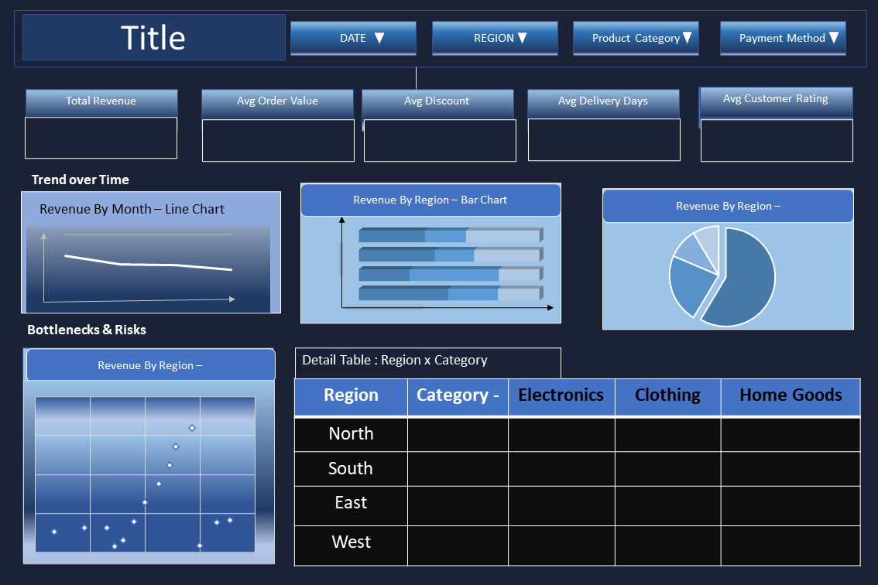
Figure 1: Wireframe of the Executive Overview dashboard showing KPIs, trend, breakdowns, bottleneck view, and detail table.

6.2 Mock-up: User Interaction Flow
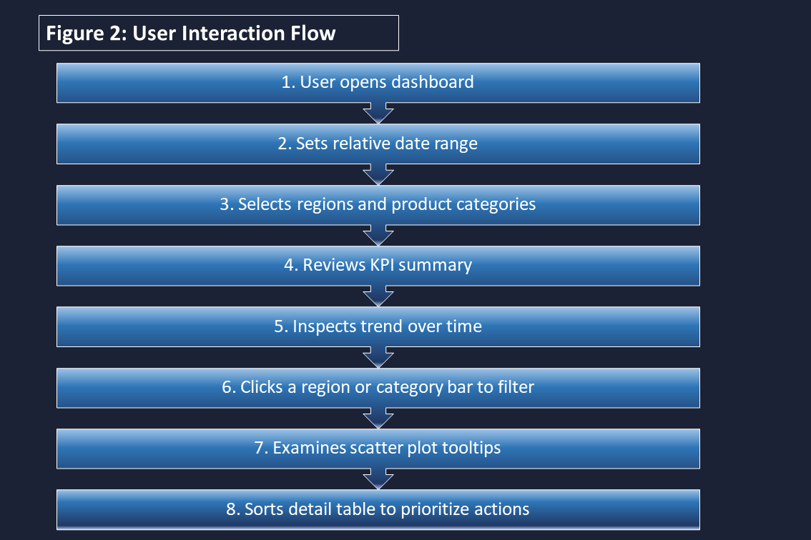
Figure 2: User interaction flow showing how the marketing manager moves from overview to action.

7. Implementation Notes (Brief)
- Data Source: Single CSV/Excel file with columns
  - order_id
  - order_date
  - customer_id
  - product_category
  - region
  - quantity
  - unit_price
  - discount
  - payment_method
  - delivery_days
  - customer_rating
  - revenue
- Refresh Frequency: To be defined (e.g., weekly or monthly).
- Performance Considerations:
  - Use aggregations for KPIs and charts.
  - Limit detail table to top N or filtered subsets if data grows large.

